THE EFFECT OF ONLINE TRANSPORTATION SYSTEM ON UNEMPLOYMENT RATE AND PUBLIC WELFARE AT INDONESIA

Darwis Harahap, Ferri Alfadri
(Faculty of Economic and Islamic Businessof IAIN Padangsidimpuan)
Jl. T. Rizal Nurdin. 4,5 Sihitang – Kota Padangsidimpuan 22733

darwisharahap@iain-padangsidimpuan.ac.id
ferrialfadri2809@gmail.com

Abstract
The aim of this study was to examine the effect of online transportation system on the unemployment and public welfare in Medan City, Indonesia. Technology-based business practices in the industrial era 4.0 require certain skills in the area ofwork. Furthermore, changes to the technology system which initially absorbed more workers tend to decrease due to it replacing human role. Consequently, the level of public welfare will also decline. This study was carried out at PT. GO-JEK Indonesia using the Structural Equation Modeling (SEM) method. The model used was a loading factor constructed from each indicator. The results of this study showed that onlinetransportationhas an effect on the reduction of unemployment rate. Furthermore, it showed that this system may improve the welfare of the public. Therefore, online transportation has a positive effect in reducing unemployment and improving public welfare.

Keyword:online Transportation, Unemployment, Public Welfare, PT. GO-JEK

INTRODUCTION
According to World Economic Forum and The Future of Jobs Report from 2015 to 2020, there are 5 human Resources capabilities in the industrial era 4.0. They include complex problem solving, social skills, process skills, system skills and cognitive abilities. Furthermore, at the end of 2020, it is estimated that the most needed skill will be cognitive abilities, followed by system skills, complex problem solving, content skills and process skills. These are needed in other to be prepared for the industrial era 4.0. It was seen that there has been a change in the positionof cognitive abilities skills with regards to acquisition in this era. This was because it increased from the last to first position in 2020 and therefore,has become an attraction and also a problem for individuals.
However, the industrial era 4.0 encourages humans to live in two worlds, namely the real and virtual world, as it relates to the existence of a system,which forces individuals to acquire personal abilities. In addition, communication is highly dependent on the virtual world which continues to increase both in the complicated and smart stages.Consequently, this will have a negative impact on the work system because the change minimizes the use of labour due to it replacing human role.
Furthermore, there was a significant difference between the increase in workforce and employment opportunities according to the level of education. It proves that an increase in educational levelleads to a potential rise in unemployment (Suryadi, 1994).
As one of the responses in recent years from the utilization of the 4.0 era, various options have emerged for both the educated and uneducated, which enables them to work and earn. One of the options was by utilizing technology assistance on existing gadgets/smartphones, i.e. the online transportation system. However, there was still unemployment registering to the company with this system includingthose who were already working (Ministry of Home Affairs, 2018). Therefore, this has triggered an increase in the number of drivers with the online transportation system.In addition, there were various underlying reasons to why the consumers prefer this application. Therefore, online transportation system is considered cheaper and faster by 84.1%and 81.9% respectively.

Figure 1. Consumers using onlinetransportation system application:
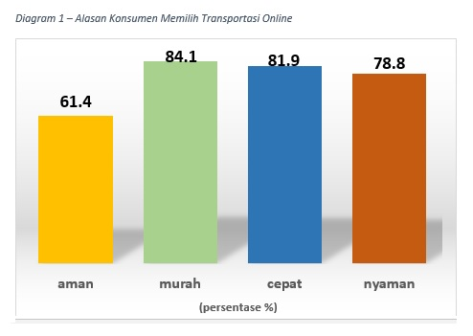
From the figure above, the reason for majority of the consumers was the price factor. The community considers the online transportation system cheaper and faster compared to others (riska, 2018).Furthermore, as the use of this application increases, very effective job opportunities will be created in the form of online transportation drivers. Therefore, the number of individuals working as drivers will continue to increase such as in PT. GO-JEK and Grab Indonesia.
In line with the branch opening rate of PT.GO-JEK in 50 cities, the unemployment rate has also been quite volatile.Based on macro factors, it was analyzed that unemployment is one of the major aspects influencing the welfare level of Indonesians. This was respectively reviewed from:

- Economic Aspect: This has an effect because poverty increases when individuals do not have a source of income to meet their daily needs.
- Political aspect:The increasing rate of unemployment and difficulty in securing jobs causes violet demonstrations, which leads to an unstable political world.
- Mental aspects: The increase in unemployment decreases the level of self-confidence which leads to depression.
- Social aspects: With high levels of unemployment, the rate of poverty, number of beggars, homeless people, including buskers around the community increases.
- Security aspect: the increasing rate of unemployment leads the unemployed into committing crimes to support the economy in the household(riska, 2018).

Therefore, thepublic welfare in a country is measured from the effectiveness level of the workforce.

THEORITICAL REVIEW:
- Online Based Transportation
Some definitions of onlinetransportation proposed by experts are as follow: (Pandesolang, 2018)
- According to Ellen, online transportation system is a form of utilizing technological developments to support the development of work areas and national economy.
- According to Doni, an online transportation system is a form of transportation which operates by utilizing thedevelopment knowledge in information technology.

Along with the development of time, the number of drivers increases in every region. In addition, individuals choose to focus on being drivers and making it their main source of income because they feel comfortable while working for reasons, such as Flexible Working Hours, Greater Income, Hobby, Part-time, Love to Meet New Peopleand Experiences from new Places (Okezon, 2018).

- Manpower
According to Law NO. 13 of 2003 concerning the use of manpower, all things are interconnected between workers before, during or after their employment (Kemenprint, 2017).In 1970s, Central Bureau of Statistics established a working age limit of 10 years. However, since the SAKERNAS (National Labor Force Survey) was held, the results have changed the working age limit to above 15 years according to recommended regulation by International Labour Organization (ILO) (Handayani, 2016).

- Unemployment
Some definitions of unemployment according to experts are as follows:
- Unemployment is defined as a situation in which a person belonging to the labour force is either not currently working or actively looking for job opportunities (Nanga, 2005).
- Unemployment is a factor which leads to a constrained economic growth. It also causes a reduced income stream for individuals which lead to poverty.

This promotes the government's effort to open up job opportunities, both in the public and private sector. Unemployment is also influenced by important factors such as Number of Employment Opportunities, Capital and Education Level (Sadono Sukirno, 2006).

- Public Welfare
Coordinating Ministry for People's Welfare defines welfare as a condition in which basic needs are met. They include food, clothing, health, education, housing, employment, a safe and comfortable environment. It is also defined as the fulfillment of the needs for the realization of moral society to Allah Subhanawata'ala (www.menkokesra.go.id, 2017).
According to Central Statistics Agency (BPS), interpreting the benchmarks of changes in the level or standard of social welfare has been studied in several fields.They include Population, Income, Education, Employment, Consumption Patterns, Health, housing environment and other social standards which are used as benchmarks in an effort to promote a better life quality (www.bps.go.id, 2017).

METHODOLOGY
This study used primary data in the form of questionnaires and interviews as initial observations. Furthermore Component Based Structure Equation Model (SEM) data analysis technique assisted by Smart PLS 3 program tool was used.

DISCUSSION OF RESEARCH FINDINGS
- Respondent Characteristics
Table 1.
Driver Gender
No | Gender | Total
1 | Male | 80
2 | Female | 20
TOTAL |  | 100

Table 2.
Driver Age
No | Age | Total
1 | 18 – 25 Years | 30
2 | 26-36 Years | 60
3 | > 36 Years | 10
TOTAL |  | 100

Table 3.
Driver Education Level
No | Education | Total
1 | Junior High School/equivalent | 8
2 | Senior High School/equivalent | 65
3 | Diploma-III/Bachelor/equivalent | 25
4 | >Bachelor | 2
TOTAL |  | 100

Table 4.
GO-JEK Driver Income
No | Income/Month | Total
1 | IDR 500.000 - IDR 1.000.000 | 5
2 | IDR 1.000.000, - IDR 2.000.000 | 20
3 | IDR 2.000.000 - IDR 3.000.000 | 60
4 | IDR 3.000.000 - IDR 5.000.000 | 15
TOTAL |  | 100

- Structural Analysis of Equation Modeling with Smart PLS
- Data Quality Test
The reliability of forming construct was measured using the composite reliability items. In accordance with the opinion expressed by Imam Ghozali, the forming construct is declared reliable when the composite reliability is >0.60 (Ghozali, 2006).
Based on the results of statistical tests, it showed that each constructvariable was considered reliable or fit. This implies that each question indicator size used as a construct was declared good, i.e. > 0.9. The processed reliability test results are seen in table 5 below.
Table 5.
Composite reliability
Forming Construct | Composite reliability
Online Based Transportation | 0.942
Unemployment Rate | 0.919
Welfare | 0.932

The individual reflective measure was high when the correlation value was> 0.50 in the measured construct. Constructs with loading factor of> 0.5 were used as the benchmark of this study, while those<0.5 were declared not good (Fatwa Tentama&Subardjo, 2018). Measurement of discriminant validity was reviewed through the results of data processing with cross loading items on forming construct. When the correlation between the forming construct indicators produced higher valuescompared to others, a good discriminant validity was formed.

Table 6.
Cross loading indicators between constructs

NO | Indicators | Online Transportation | Unemployment Rate | Public welfare
1 | PL1 | 0.740 | 0.916 | 0.920
2 | PL2 | 0.842 | 0.811 | 0.795
3 | FX1 | 0.908 | 0.889 | 0.857
4 | FX2 | 0.710 | 0.617 | 0.616
5 | HB1 | 0.871 | 0.812 | 0.861
6 | HB2 | 0.704 | 0.653 | 0.646
7 | PT1 | 0.713 | 0.629 | 0.673
8 | PT2 | 0.857 | 0.832 | 0.857
9 | SB1 | 0.627 | 0.581 | 0.652
10 | SB2 | 0.557 | 0.561 | 0.469
11 | PB1 | 0.531 | 0.472 | 0.415
12 | PB2 | 0.954 | 0.916 | 0.920
13 | LP1 | 0.746 | 0.810 | 0.743
14 | LP2 | 0.699 | 0.722 | 0.717
15 | MO1 | 0.932 | 0.954 | 0.925
16 | MO2 | 0.657 | 0.767 | 0.685
17 | TP1 | 0.596 | 0.601 | 0.574
18 | TP2 | 0.921 | 0.958 | 0.929
19 | PDT1 | 0.522 | 0.505 | 0.619
20 | PDT2 | 0.637 | 0.624 | 0.715
21 | KO1 | 0.820 | 0.752 | 0.808
22 | KO2 | 0.577 | 0.626 | 0.715
23 | KES1 | 0.722 | 0.722 | 0.761
24 | KES2 | 0.719 | 0.688 | 0.756
25 | LK1 | 0.851 | 0.882 | 0.853
26 | LK2 | 0.668 | 0.714 | 0.779
27 | KS1 | 0.836 | 0.818 | 0.835
28 | KS2 | 0.725 | 0.750 | 0.757

Based on the standard values used to assess the validity level, the data in this study were categorized as valid because the data findings were > 0.5 (Ghozali, 2006).
Structurally,it was evaluated using the results of R-square test on dependent variable (Z and Y) and t-statistical data test including the significance of structural path coefficient value. The R-Square test results with Smart PLS are seen in table 7 .

Table 7.
R-Square
Variables | R-Square
Unemployment | 0.856
Welfare | 0.802

- Research Model
The results of data testing were assisted by the Smart PLS3 software tool.The path diagram used in this study is as follows.

Figure 2. Structural Model of Research Equation Modeling
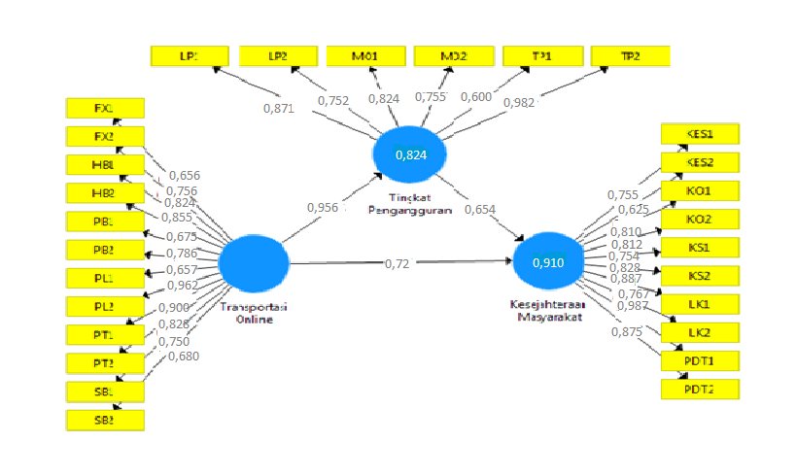
The model formed is seen from the loading factor created by each indicator. It is also listed in table 8 below.
Table 8.
Outer Loading Model
No | Indicators | Online-based Transportation | Unemployment Rate | Welfare
1 | PL 1 | 0.657
2 | PL 2 | 0.962
3 | FX 1 | 0.656
4 | FX 2 | 0.756
5 | HB 1 | 0.824
6 | HB 2 | 0.855
7 | PT 1 | 0.900
8 | PT 2 | 0.828
9 | SB 1 | 0.750
10 | SB 2 | 0.680
11 | PB 1 | 0.675
12 | PB 2 | 0.786
13 | LP 1 |  | 0.871
14 | LP 2 |  | 0.752
15 | MO 1 |  | 0.824
16 | MO 2 |  | 0.755
17 | TP 1 |  | 0.600
18 | TP 2 |  | 0.982
19 | PDT 1 |  |  | 0.987
20 | PDT 2 |  |  | 0.875
21 | KO 1 |  |  | 0.810
22 | KO 2 |  |  | 0.812
23 | KES 1 |  |  | 0.755
24 | KES 2 |  |  | 0.625
25 | LK 1 |  |  | 0.887
26 | LK 2 |  |  | 0.987
27 | KS 1 |  |  | 0.754
28 | KS 2 |  |  | 0.828
The loading terms used were > ± 0.30, loading > ± 0.40 is declared urgent and loading > ± 0.50 is significant. From the table above, it was explained that the modeling of the indicators tested was declared fit because all loading factors were > 0.50. Furthermore, the model used on this study was seen through the results of the validity and reliability on the forming construct indicators (Ghozali, 2006).
- Construct Validity Testing
This aims to determine the T-statistic value for each construct indicator. Indicators with T-statistic value ≥ 1.96 are declared valid. Theyare also declared when the P-value is ≥0.05. From the Bootstraping calculation of the modeling test, Outer Loading was obtained(Ghozali, 2006).
Table 9.
Outer Loading
Indicators | Original Sample (O) | Sample Mean (M) | Standard Deviation (STDEV) | T Statistics (/O/STDEV/) | P Values
PL1 <-Online Based Transportation | 0.740 | 0.739 | 0.058 | 12.810 | 0.000
PL2<-Online Based Transportation | 0.842 | 0.841 | 0.030 | 28,122 | 0.000
FX1<-Online Based Transportation | 0.908 | 0.907 | 0.026 | 35.114 | 0.000
FX2<-Online Based Transportation | 0.710 | 0.711 | 0.077 | 10.197 | 0.000
HB1<-Online Based Transportation | 0.871 | 0.870 | 0.036 | 24.452 | 0.000
HB2<-Online Based Transportation | 0.704 | 0.697 | 0.056 | 12.571 | 0.000
PT1<-Online Based Transportation | 0.713 | 0.707 | 0.065 | 10.954 | 0.000
PT2<-Online Based Transportation | 0.857 | 0.858 | 0.029 | 30.011 | 0.000
SB1<-Online Based Transportation | 0.627 | 0.623 | 0.085 | 7.420 | 0.000
SB2<- Online Based Transportation | 0.557 | 0.560 | 0.065 | 8.508 | 0.000
PB1<- Online Based Transportation | 0.531 | 0.529 | 0.081 | 6.526 | 0.000
PB2<- Online Based Transportation | 0.954 | 0.954 | 0.007 | 132.101 | 0.000
LP1<- Unemployment Rate | 0.810 | 0.805 | 0.046 | 18,709 | 0.000
LP2<- Unemployment Rate | 0.722 | 0.720 | 0.055 | 13.182 | 0.000
MO1<-Unemployment Rate | 0.954 | 0.954 | 0.008 | 25,359 | 0.000
MO2<-Unemployment Rate | 0.767 | 0.764 | 0.055 | 13.959 | 0.000
TP1<-Unemployment Rate | 0.601 | 0.604 | 0.080 | 7.580 | 0.000
TP2<-Unemployment Rate | 0.958 | 0.959 | 0.006 | 149.416 | 0.000
PDT1<Welfare | 0.619 | 0.615 | 0.085 | 7.326 | 0.000
PDT2<Welfare | 0.715 | 0.711 | 0.057 | 12.455 | 0.000
KO1<Welfare | 0.808 | 0.807 | 0.045 | 18.072 | 0.000
KO2<Welfare | 0.715 | 0.708 | 0.081 | 8.765 | 0.000
KES1<Welfare | 0.761 | 0.763 | 0.067 | 13.245 | 0.000
KES2<Welfare | 0.756 | 0.755 | 0.059 | 12.825 | 0.000
LK1<Welfare | 0.853 | 0.856 | 0.035 | 24.998 | 0.000
LK2<Welfare | 0.779 | 0.780 | 0.076 | 10.245 | 0.000
KS1<Welfare | 0.835 | 0.835 | 0.035 | 20.780 | 0.000
KS2<Welfare | 0.757 | 0.757 | 0.057 | 23.419 | 0.000
Based on the results of the data test in table 10, it was stated that each forming construct indicator hada T-statistic result >1.96 and P-Value < 0.05. Therefore, all formed constructs were declared valid and used as a measure for hypothesis testing at the stage structural measurement.

- Structural Model Evaluation
Evaluation on analysis model is needed to assess the significance level of the correlation between constructs assessed through T-statistics obtained from the output of processed data testing by calculating PLS Bootstraping. The influence rate between constructs and interactions which occured was measured by the amount of path coefficient value created. The path coefficient created by T-statistic value ≥ 1.96 and P-value ≤0.05 was stated to have a significant effect (Ghozali, 2006).
With the help of Smart PLS software, path diagram with T-statistic value was created. Table of path coefficients is shown in Figure 4.3 below:
Figure 4. T-statisticand Path Diagram
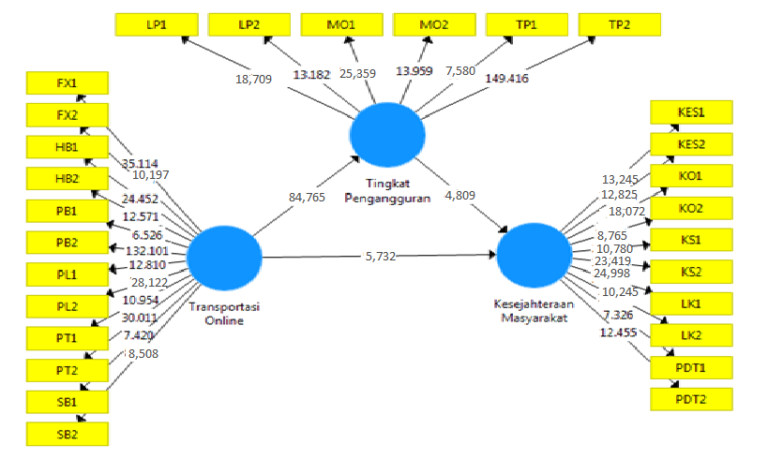

Table 10.
T-test and P-Value
 | Original Sample  (O) | Mean (M) | Standard Deviation (STDEV) | T-Statistic (/O/STDEV/) | P-Values
OnlineTransportation ->  Welfare | 0.524 | 0.528 | 0.082 | 5.732 | 0.000
Online Transportation ->  Unemployment | 0.976 | 0.948 | 0.021 | 84.765 | 0.000
Unemployment->  Welfare | 0.453 | 0440 | 0.083 | 4.809 | 0.000

Based on the data test results, the hypothesis testing was carried out by comparing T-Value with a significance value of 0.05. When T-Value was ≥ 1.96 or P-Value was ≤ 0.05, H0 was rejected and H1 accepted.

DISCUSSION OF RESEARCH HYPOTHESIS
- Online Transportation System in reducing the unemployment rate.
Based on the statistical data test results, it was stated that the forming constructs of the online transportation system had a significant positive effect on the reduction of unemployment. This was proven from the t-statistical test value which was>1.96,i.e equal to 84.765 and H1 was accepted.
Therefore, it was stated that the presence of job opportunities as drivers in the online transportation system was an alternative solution to minimize unemployment growth.

- Influence of onlinetransportation systems onpublic welfare
Based on the results of statistical data test processing, it was stated that theforming constructs of the online transportation system hada significant positive effect on public welfare. This was proven from the measurement of t-statistic value which was > 1.96, i.e 5.732 and H1 was accepted. Therefore, it was stated that the emergence of job opportunities as drivers in the online transportation system was able to improve the lives of GO-JEK drivers and their families.

- The effect of online transportation on public welfare through reducing the unemployment rate
Based on the results of the statistical processing, it was stated that the forming constructs of the online transportation system had a significant positive effect on public welfare. This was proven by the t-statistic value which was > 1.96, i.e 4.809.
Furthermore, Itwas concluded that H1 is accepted as a whole. Therefore, this proves that the presence of job opportunities as drivers in Online transportation systems was able to reduce the unemployment rate and also improve people's lives (GO-JEK drivers, their environment and families).

REFERENCES
Erutan, Agas PunuAnto', Jurnal Ilmu Sosial dan Ilmu Politik , ISSN 1,410-4946, Volume 10, Nomor 3, Maret2} A7 Q95-324)
Ghozali, Imam, Struktural Equation Modeling Metode Alternatif dengan Partial Least Square, (BadanPenerbitUniversitasDiponegoro, 2006),
Handayani, eprints.walisongo.ac.id
http://rubik.okezone.com/read/40747/10-alasan-menjadi-driver-transportasi-online
Kaufman, Bruce E Julie L.Hotchkiss, The Economics Of Labor Market,Yogyakarta 1999, BPFE UGM
Martati, Indah, Jurnal Manajemen Dan Kewirausahaan/Jmk, Vol.15, No. 2, September 2013: 123-130
Muana, Nanga, Makro Ekonomi Teori Masalah dan Kebijakan, (Jakarta, PT.RajaGrafindoPersada, 2005)
Pandesolang, e-journal.uajy.ac.id/7732/3/TA213706.pdf
Riska, Franita, Analisa Pengangguran di Indonesia, Nusantara( Jurnal Ilmu Pengetahuan Sosial ), Volume 1 Desember 2016, ISSN 2541-657X
Sukirno, Sadono, Makro Ekonomi Teori Pengantar, (Jakarta: PT. Raja Grafindo Persada, 2006)
Tentama, Fatwa &Subardjo, Jurnal HUMANITAS, Pengujian Validitas dan Reliabilitas Konstruk Pada Organizational Citizenship Behavior, ISSN 1693-7236, Vol. 15, No.1
www.BPS.go.id
www.kemenperin.Go.id/Kompetensi/UU_13_2003
www.menkokesra.go.id.,

